 | St. Mary’s Primary and Pre-school Newsletter (4) |  | 13th October 2025
SCHOOL MISSION STATEMENT  We come together as Saint Mary’s family, to learn, share our faith and do our best, to follow in the footsteps of Jesus.  WINMARLEIGH  We are really excited to be setting off today to Winmarleigh outdoor residential with years 4/5/6. Mrs. Morris, Mrs. Jardine and Mrs. Hutchings will be accompanying the children. There will be an assembly a week on Friday in school(24th) at 2.45pm celebrating their adventures. Please do come if you can.  HARVEST FESTIVAL  Thank you for all your very kind donations of dried and tinned food goods for our Harvest boxes. The children took them out into the community last Friday where we are sure they will be enjoyed. On Thursday morning of this week, yrs 4/5/6 have been invited to St. Bart’s for a ‘Harvest Experience’ organised by Rev. Wilma. We will look forward to this and we are very grateful to her for asking us.  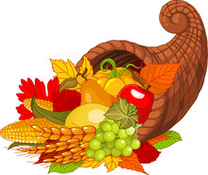  The children have also made ‘Happy Harvest’ cards for our friends and neighbours in the community. |  | FAMILY MASS  The next family mass is Sunday, 19th October at 9.30am. Please can you try to support if possible? We need children to take part by reading bidding prayers and taking up the offertory as well as singing their hearts out! We will be asking children this week if they are able to contribute to Mass so please can you let them know if you are able to attend. Thankyou in anticipation.  CHILDREN IN NEED  Children in Need is on Friday 14th November. As always, we will try to raise money for this wonderful cause. We will be holding a bake sale so the children can bring in some money for that. We will also have a sponsored ‘something.’ We will talk to the school council and see what ideas they come up with. It will also be a non-uniform day – again, ideas from the school council.  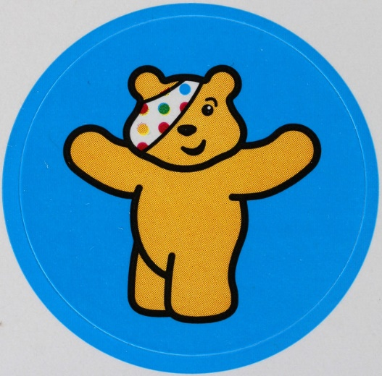
 | Whats Happening?

Dates for your diary……

Scholastic Book Fair
We will be holding our book fair in school from Wed 8th Oct from 3.15pm until 4pm every afternoon at the end of school until Tues 14th Oct. It will leave on the 15th Oct. It’s an opportunity to buy Christmas presents with lots of great bargains to be had. Also, school can take a percentage of whatever we make in books which then go to our school library. Please do come and support if you are able to.

Mass in Church
(please do join us if you can as the children sing so beautifully and read so well) on Thursdays, 9.30am – 10am

6th November
4th December
18th December

Book fair in School, Wednesday 9th October until Tuesday 15th October (3.15pm – 4pm)
Winmarleigh Outdoor Residential Outdoor Pursuits yrs 4/5/6 – October 13th to 15th
Open the book – October 21st
Bradshaw’s Farm Shop for Pumpkin picking, Pre-school and Reception - October 22nd
Parents Evening – October 22nd
Break up for half term – Friday, 24th October

Family Masses at St. Mary’s, Chipping
19th October
23rd November
21st December

Looking ahead …………
29th Nov, Chipping Christmas Fair at the village hall
6th Dec, Xmas bingo at the village hall 6pm
15th Dec, Rapunzel Panto at Preston
16th Dec, EYFS and KS1 Nativity (10am and 2pm)
17th Dec, Christmas Dinner and Party Day
18th Dec, Carol Service in school at 2pm

