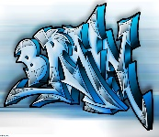

## English

**Year 4**

The Iron Man – novel as a theme

**Years 5 and 6**

Older literature

Information text hybrid

Poetry

## Maths

**Year 4 –** multiplication and division, measurements and fractions

**Year 5 –** multiplication and division and fractions

**Year 6 –** decimals, percentages and algebra

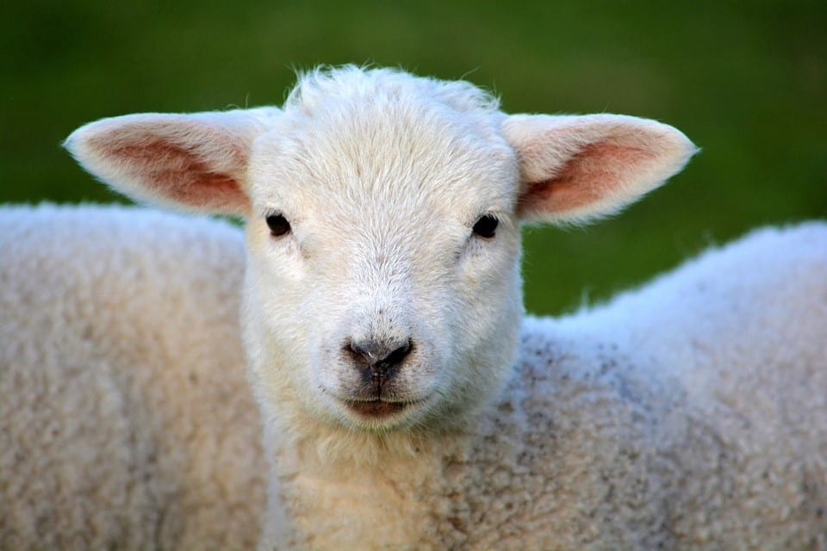

# **Years 4,5,6**

# **Spring 2025**

**Miss Grice**

**Enrichment Activities -**

A visit from a Viking.

Learning songs for ‘Lancashire Sings at Preston’

## PE

PNE will be in school and will be covering athletics for this half term.

**Art – Vikings**

To support our history topic, we will be learning about and creating our very own Viking art! We will look at artifacts such as parts of long boats to see the art from this time.

**RE – Baptism and Marriage/Eucharist**

Children will explore the sacrament of marriage and what it means to be married. They will explore commitment and how we can be committed to God as well as to each other.

Children will also learn about Eucharist and the importance of the events of the Passover.

**History – Anglo-Saxons vs Vikings**

We will be learning all about what it was like to live in Britian during the time of the first Viking invasions. We will learn all about the rulers of the divided kingdoms and when the kingdoms became united.

## Computing – Databases

We are going to be using Purple Mash to learn all about what a database is and how it works. We will learn how databases are used in everyday life and have a go at creating our own.

## Science – Changes of Materials

We will be learning all about properties of materials and how these properties can influence changes to them. We will discover reversible and irreversible changes and have a go at a few experiments!

## Music

Unit 2 of Charanga - Blackbird

Music of Franz Liszt

Rapping rhythms