

## English –

## Fire! Fire! (Year 1 and 2)

Repetitive pattern stories

Non-chronological reports

Poems on a theme

**The Iron Man (Year 3)**

Novel as a theme

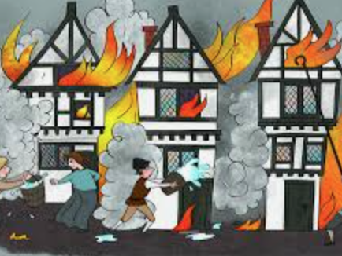

## PE

PNE will be in school and will be covering athletics for this half term.

## Science – Everyday Materials

The children will identify objects and the material from which it is made. As well as, identify and name a variety of everyday materials, including wood, plastic, glass, metal, water, and rock. The children will describe the simple physical properties of a variety of everyday materials and compare and group together a variety of everyday materials on their simple physical properties.

**Art – Drawing**

The children will experiment with a variety of different media; pencils, rubbers, crayons, pastels, charcoal and chalk. The children will experiment with shading and tone, and working on a small and large scale.

**DT – Structures**

The children will design and construct their own house, inspired by the homes / bakery on pudding Lane during the time of The Great Fire of London.

**History – The Great Fire of London**

During this topic, the children will explore what happened during The Great Fire of London, why the fire spread so quickly and what it may have been like to live there during this time. As well as, how fire was extinguished. Using pictures the children will make comparisons between modern day London and London before the fire of 1666. We will learn about Samuel Pepys and the diary he kept throughout that time.

**RE – Local Church and Community: Journeys**

Within this topic, the children will explore the different events in which we mark throughout the liturgical year. We will look in detail at the liturgical calendar and the different times that make it up. The children will also continue to discuss the importance of prayer and how we can help others.

## Computing - Spreadsheets

## Music – London’s Burning

The children will listen to a variety of different music ‘inspired’ by fire from across many years. They will learn well known songs which they will sing in unison. This is will lead to the children choosing one of the songs to perform in a small group with it being sung in two parts.

# **Years 1,2,3**

**Spring 1 2025**

**Mrs Jardine**

## Maths

**Year 1 –** Addition within 20, Subtraction within 20 and numbers to 50

**Year 2 –** Multiplication and Division, Statistics, Length and Height

**Year 3 –** Multiplication and Division, Money and Statistics