

**Phonics**

In Pre-School, our younger 2-3s will be completing Phase 1 phonics activities, focusing on listening and attention skills. Our rising 3-4s will be focusing identifying initial sounds words.

Reception will be continuing their Read Write Inc. phonics programme. They will be learning how to include finger spaces between their words in order to form short sentences.

## Maths

Pre-School –learning to count out and give amounts up to 5. To match, sort and compare collections of amounts.

Reception **–** consolidating and comparing numbers to 10. To understand early addition within 10.

**RE**

This half term we will be learning about our local church community. We will understand the meaning of ‘community’ and recognise the different areas/symbols within our church. We will also be looking at the story of ‘The Presentation’ and retelling this story using small world figures.

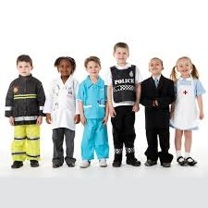

**Topical learning**

This half term we will be learning about the important jobs that adults do to help us. We will be creating our own information booklets all about these important jobs. We hope to visit our local fire station, have visits from nurses, the police and many other professions. – if our parents know of anyone willing to come into school to support us with this topic, please get in touch!

**Forest Friday**

We will be looking at how the outdoor environment changes during the cold winter months. We will be learning den making skills using tarpaulin and string.

## Music

Learning new hymns in class worship, listening to the songs from ‘Lancashire Sings at Preston’ and moving to different pieces of music.

## PE

PNE will be in school and will be covering athletics for this half term.

# **Pre-School & Reception**

**Spring 1 – People Who Help Us**

**Miss Bennett**

**Enrichment Activities**

Fire station visit

Supermarket visit

Guest speakers – people who help us!

**PSHE-** Rights and Responsibilities

This half term we will be looking at our rights and responsibilities within our community. This includes caring for the environment, litter picking, learning how to be a good friend to others and how to save and spend money wisely.