

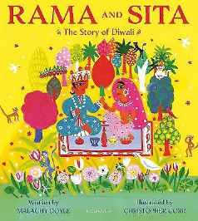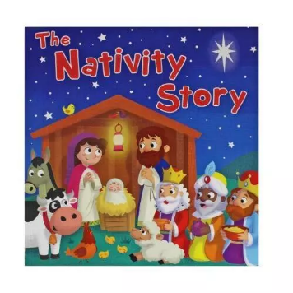

**Phonics**

Pre-School will be completing Phase 1 phonics activities, focusing on listening and attention skills.

Reception will be continuing their Read Write Inc. phonics programme. They will be developing fluency when reading three letter words and tricky red words, such as ‘the’, ‘I’ and ‘to’.

## PE

Ball skills and invasion games.

**RE –** Advent/Christmas: Loving

Children will learn how we enter the Church family through Baptism. They will be able to explain what happens in a Baptism.

Children will also learn about Advent and how Christmas is a time to celebrate the birth of Jesus.

## Music – We will be working with ‘Little Voices’ learning our Nativity songs ready for our play.

**Enrichment Activities -**

Pantomime trip

Pre-School swimming

# **Pre-School & Reception**

**Autumn 2 - Celebrations**

**Miss Bennett**

**PSHE**

The children will be learning about how to keep themselves safe and keeping their bodies healthy. We will discuss road safety and keeping safe online.

**Topical learning**

Bonfire Night- learning about the story of Guy Fawkes and the Gunpowder Plot.

Remembrance Day- looking at symbols of remembrance such as a poppy and discussing the bravery of soldiers in the war.

Diwali- Retelling the story of Rama and Sita. Creating our own Diya lamps and rangoli patterns for this Hindu celebration.

Nativity- Learning about and retelling the Christmas story and looking at how we celebrate Christmas today.

**Forest Friday**

We will be exploring our outdoor area, identifying hazards, and learning about the season of Autumn.

## Maths

Pre-School –exploring repeats, patterns and identifying numbers 1-3.

Reception **–** 2D shapes, one more and one less, number bonds to 5, and positional language.