

## English –

## There’s No Place Like Home (Year 4)

Folk Tales

Biographies

**A Kingdom United (Years 5 and 6)**

Legends

Persuasion

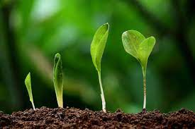

**Enrichment Activities -**

Whinmarleigh residential trip

Stoneyhurst visit

**Art – Pop Art and Andy Warhol**

Children will discover the pop art movement. They will learn about Andy Warhol and his most famous pieces. They will create their own pieces of art that are inspired by Andy Warhol’s work using the same techniques.

**History – Iron Age to Stone Age**

Children will learn about prehistory and the evidence we have about this time. They will discover what life was like for humans and how this differs from life today. They will discover and compare the daily lives of humans from the Iron Age, Bronze age and Stone Age.

## PE

Gymnastics (PNE)

## Computing

Coding and computer safety

## Music

## We will be working with ‘Little Voices’ learning how to sing using expression and dramatic effect.

**RE – Ourselves**

Children will learn about the qualities God has given them and how they can use them to make a positive difference to the world. They will learn about people who have done this such as Maximillian Kolbe and Mother Teresa.

## Science – States of matter

## Children will identify and compare states of matter. They will understand and describe the processes of changing states of matter. Children will experience these changes through experiements.

## Maths

**Year 4 –** Place value

**Year 5 –** Place value within 100,000

**Year 6 –** Place value within 10,000,000

# **Years 4,5,6**

**Autumn 2024**

**Miss Grice**