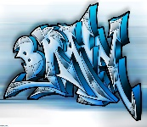

## English –

## Penguins, Possums and Pigs (Year 1 and 2)

Stories with familiar settings

Non-chronological reports

Poems on a theme

**There’s No Place Like Home (Year 3)**

Folk Tales

Biographies

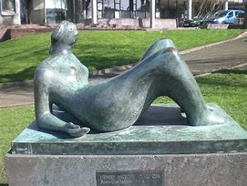

## PE

Gymnastics (PNE)

**History – The History of Chipping**

During this topic the children will learn about the different historical buildings within Chipping. They will also look closely at both St Mary’s schools, comparing what it would have been like to attend the old St Mary’s School.

## Computing

Online Safety and Maze Explorers

**RE – Family and Baptism**

Children will learn about the Holy Family and understand God’s vision for every family within the home.

They will learn about the sequence of a Baptism and understand the commitment and promises made during a Baptism.

## Music –

## We will be working with ‘Little Voices’ learning how to sing using expression and dramatic effect.

**Enrichment Activities -**

Walk around Chipping

A visit from the historical society.

**Art – Sculpture**

Children will look at art work by Henry Moore. The children will use various techniques to create sculptures in the form of a human, using Henry Moore as inspiration. They will use different materials such as; pipe cleaners, play dough and clay. The children will work towards planning and designing their own sculpture, making it and then evaluating their final model.

## Science – Plants

## Children will observe changes across the four seasons. They will describe weather associated with seasons and how day length varies.

## Maths

**Year 1 –** Numbers to 10, Part-Whole within 1 and Addition and Subtraction within 10.

**Year 2 –** Numbers to 100 and Addition and Subtraction.

**Year 3 –** Place value within 1000 and Addition and Subtraction.

# **Years 1,2,3**

**Autumn 2024**

**Mrs Jardine**