 | St. Mary’s Primary and Pre-school Newsletter (8)  SACRAMENTAL PROGRAMME  The sacramental program that should have been running this week has been postponed until next week due to the heating not working in Church. Father Tony has apologized and hopes it doesn’t spoil too many plans.  MINI SKILLS COMPETITION  Children from years 1 and 2 will be taking part in a mini-skills competition at West View Leisure Centre next Tuesday, 30th January. More details to follow.  VISIT TO STONYHURST  Miss Doherty and Mrs. Butcher will be taking years 4/5/6 to Stonyhurst on Friday, 2nd February to learn about Crime and Punishment through their History department. We are extremly grateful to Stonyhurst who are working closely with us to support our curriculum by offering their resources and classrooms for our use. It’s very exciting!  SWIMMING LESSONS  Year 2 will be going swimming this half term. Please can you ensure that the children have their swimming bags in school on Friday. Also, if PE kits haven’t been returned, please send them in ASAP. PE is on Monay afternoons. |  | 23rd January 2024
SCHOOL MISSION STATEMENT
We come together as Saint Mary’s family, to learn, share our faith and do our best, to follow in the footsteps of Jesus.

VISIT TO THE HOUSES OF PARLIAMENT
Thankyou to all our parents for sending back the forms giving permission for their children to travel down to London on Wednesday, the 7th of February.
We will have a meeting in school on Monday 29th January at 2.45pm just before home time for parents who pick up their children at 3.15pm. Obviously, some parents will not be able to attend due to work commitments so please can those parents contact us and we will arrange a date that is more convenient. However, if you just have questions that can be answered over an email, please feel free to send them over. There will be another letter coming home soon with details on so that may answer any questions that you do have.

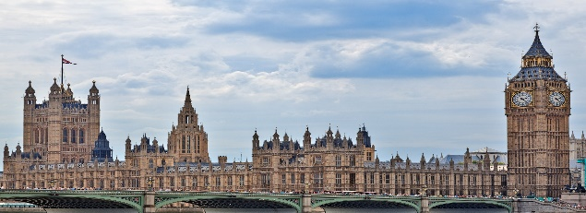

 | Whats Happening? |  | 23rd January 2024

Dates for your diary……

2nd Sacramental Programme Meeting in School for children and parents – 25th Jan, 3.30pm – rearranged for 1st February
Celebration in Church for Sacramental Programme – Sunday, 28th January, 9.30am – rearranged for 4th February
Half time penalties at PNE – Saturday, 3rd Feb
Children’s Mental Health Week – week beginning 5th February
Visit to Parliament for years 4/5/6 – 7th February
Mass in Church – Thursday, 8th February, 9.30am
Safety Town at St. Cecilia’s’ (either 8th or 9th February) for years 4/5/6
School closes for half term holiday – Friday, 9th February

School opens for 2nd half term – Monday, 19th February
Governors committee meetings – Wednesday, 21st February at 5.30pm
3rd Sacramental Programme Meeting in School for children and parents – 29th Feb, 3.30pm
Full Governors Meeting in School – Wed, 6th March, 7pm
Mass in Church – Thursday, 7th March
World Book Day – Thursday, 7th March (Harry Potter theme this year)
Reception and Year 6 height and weight check with NHS – Mon, 25th March
Maundy Thursday Mass – 28th March 9.30am
School closes for the Easter holidays – 28th March

