 | St. Mary’s Primary and Pre-school Newsletter (1)  time so as not to cause disruption to the class teacher and the other children but more importantly, that they feel ready to begin their day in school. Also, please try not to take your child/ren out of school for holidays during term time. We have always been really proud of our attendance here at St. Mary’s and we do not want it to change. The children here have always had great resilience, positivity and determination to do their best and achieve what they are capable of and that is down to parents who support their children in being in school on time every day. Even a few days off school can lead to a child falling behind – especially if it’s a key learning objective that they have missed. Of course, children get ill occasionally, so if you are concerned about them, keep them at home but let us know ASAP so that we are not having to ring you to see where they are.  FRIENDS OF ST MARY’S AGM/MEETING  After a short period of being inactive, our PTFA which is called ‘ Friend’s of St. Mary’s’  will be holding it’s AGM and first meeting of this academic year on 6th Sep in school at 6.30pm. We will be looking to vote in a new Chair, Vice-Chair, Secretary, Treasurer, Publicity Officer and Committee Members / Volunteers. The more help the better and everyone is very welcome. If you think you would like to find out more or even put yourself forward for a role, please do come and join us. It will be approximately an hour long. |  | 5th September 2023
SCHOOL MISSION STATEMENT
We come together as Saint Mary’s family, to learn, share our faith and do our best, to follow in the footsteps of Jesus.

WELCOME BACK

Welcome back to school after the (very wet) summer holidays. We hope that you have all had a lovely break and that the children are raring to go with their learning and seeing their friends again. We welcome to school also our new Reception class and their class teacher Miss Rawlinson. She has been in school over the holidays getting ready to welcome the Pre-school and Reception children into school. We know that you will all make her feel welcome and allow her to settle in. If you do need to speak to her about anything, give us a call or email us in the office and we will arrange a meeting for you. Please remember that school now starts at 8.45am and the gates will open from 8.35am with a member of staff outside on the yard. It is really important that all our children arrive on time for registration and are ready to begin their lessons on

 | Whats Happening? |  | 5th September 2023

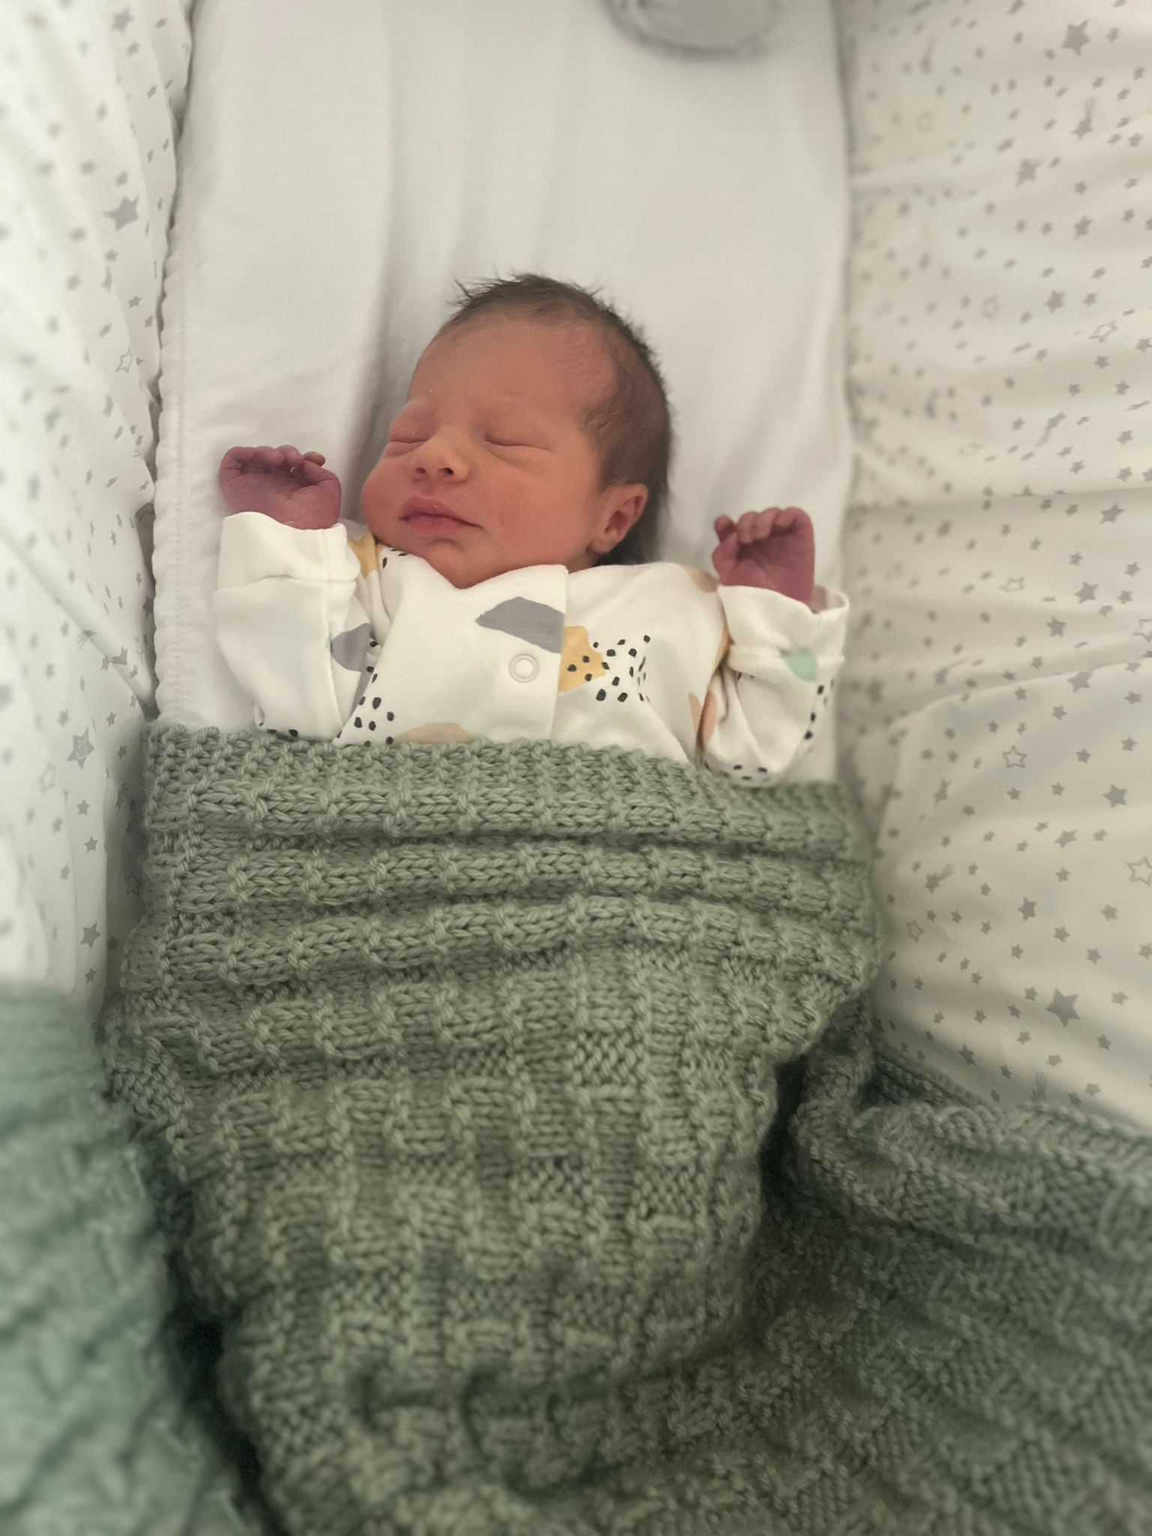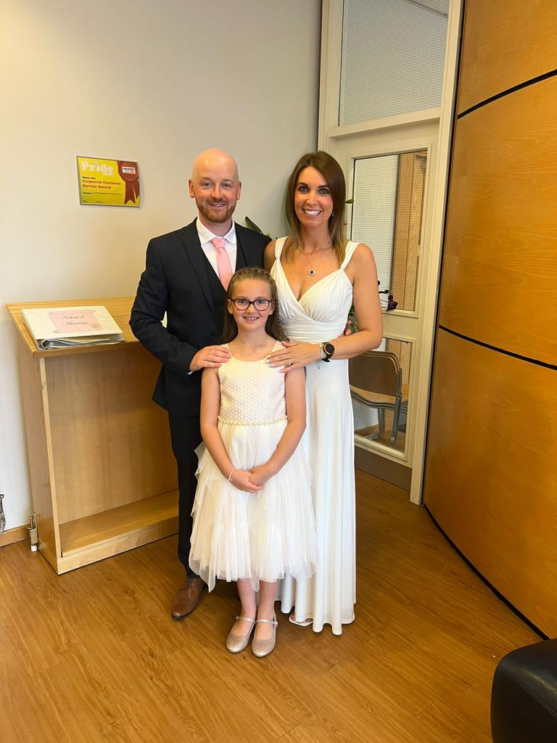
Dates for your diary……

FOSM meeting – 6th Sep, 6.30pm in school (all welcome to attend)
Celebration Assembly/class assembly every Friday at 2.45pm for all to attend
Mass in Church – 7th Sep. 9.30am
Bikeability for yrs. 4/5/6 – 18th Sep in school (level 1)
Bikeability for yrs. 5/6 – 19th Sep in school (level 2)
MacMillan Coffee Morning – 29th Sep, 9am – 10am in school
Tempest Photographs (Individual and family) 3rd Oct from 8.30am onwards in school
Mass in Church – 5th Oct, 9.30am
Miss Doherty’s class assembly – Fri 6th October at 2.45pm
Mrs. Tallentire’s class assembly – Fri 13th October at 2.45pm
Parent’s evening to discuss settling in and progress – 16th October, 3.30pm – 5.30pm
Miss Rawlinson’s class assembly – Fri 20th October at 2.45pm
Scholastic Book Fair in School – 11th Oct
Break up for the half term holidays – 20th Oct

Congratulations

The teaching staff have been busy over the holidays too. Mrs. Cowburn and Mr. Tallentire got married and Mr. and Mrs. Jardine welcomed baby Erin into the world. We wish them all the very best for the future and our love and prayers are with them all (and we can’t wait to meet Erin!) We also welcome Mrs. Walmsley back to school after her recent illness and we know that the children will be really pleased to see her.

